- \Operation\Tube print registration\Tube print registration
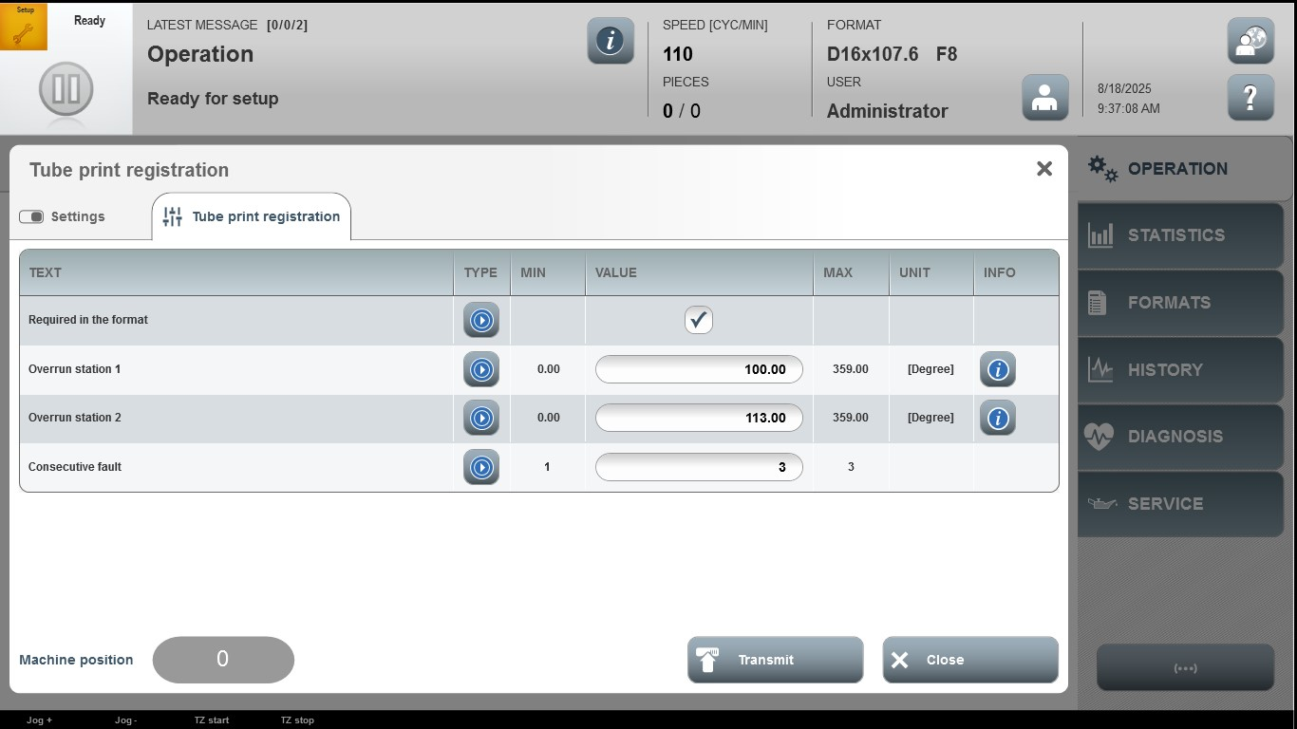

Acceptance criterion | Limits | Pass / Fail: Dev-No. | Date | Initials
Screen matches screenshot | N / A
Overrun station 1 | 0.00 …359.00
Overrun station 2 | 0.00 …359.00
Consecutive fault | 1 … 3

